电子信息学院
实验报告书

课程名：《WEB系统开发》
题 目： 实验三 Servlet实验
实验类别 【验证、设计、综合】
班 级： 软件2311
学 号： 251103530135
姓 名： 符淏

评语：

成绩： 指导教师：

批阅时间： 2025年10月9日

- 实验内容或题目
Servlet实验:编写登陆页实现三天免登陆，编写投票页。
2、实验目的与要求
掌握编写简单的Servlet代码
掌握Servlet运行环境搭建
掌握Servlet部署和请求的方法
掌握Session和Cookie的使用
- 实验步骤与源程序
⑴ 实验步骤
编写LoginServlet.java 负责登录逻辑处，LogoutServlet.java 负责签退逻辑处理，VoteServlet.java 负责投票逻辑处理，VoteUtil.java 负责投票数据工具类
编写：login.jsp登录页面welcome.jsp 登录后首页（含投票选项）votingResults.jsp 投票结果展示页
创建img文件夹存放bar.jpg
⑵ 源代码
login.jsp:
<%@ page language="java" contentType="text/html; charset=UTF-8" pageEncoding="UTF-8"%>
<!DOCTYPE html>
<html>
<head>
<meta charset="UTF-8">
<title>登录页</title>
</head>
<body>
<div class="login-box">
<h2 style="text-align: center;">用户登录</h2>
<% if (request.getParameter("error") != null) { %>
<div class="error">用户名或密码错误，请重新输入！</div>
<% } %>
<form action="<%= request.getContextPath() %>/LoginServlet" method="post">
<div class="form-item">
<label for="username">用户名：</label>
<input type="text" id="username" name="username" required>
</div>
<div class="form-item">
<label for="password">密码：</label>
<input type="password" id="password" name="password" required>
</div>
<div class="form-item">
<label>&nbsp;</label>
<input type="checkbox" id="remember" name="remember" style="width: 40px;">
<label for="remember" style="width: auto;">3天免登录</label>
</div>
<div class="form-item">
<input type="submit" class="btn" value="提交">
</div>
</form>
</div>
</body>
</html>

welcome.jsp:
<%@ page language="java" contentType="text/html; charset=UTF-8" pageEncoding="UTF-8"%>
<!DOCTYPE html>
<html>
<head>
<meta charset="UTF-8">
<title>欢迎页</title>
</head>
<body>
<div class="welcome-box">
<%
String loginUser = (String) session.getAttribute("loginUser");
String loginPassword = (String) session.getAttribute("loginPassword");
if (loginUser == null) { // 未登录或Session失效
response.sendRedirect(request.getContextPath() + "/login.jsp");
return;
}
%>
<div class="user-info">
你好, <%= loginUser %>, 欢迎回来！
<a href="<%= request.getContextPath() %>/LogoutServlet" class="logout">退出</a>
</div>
<br>
用户名：<%=loginUser %>
<br>
密码：<%=loginPassword %>
<!-- 2. 投票表单（提交到VoteServlet） -->
<form action="<%= request.getContextPath() %>/VoteServlet" method="post">
<div class="vote-title">请为你的爱好投票（可多选）：</div>
<%
String[] options = cn.edu.sdju.soft.VoteUtil.OPTIONS;
for (String option : options) {
%>
<div class="vote-option">
<input type="checkbox" name="voteOption" id="opt_<%= option %>" value="<%= option %>">
<label for="opt_<%= option %>"><%= option %></label>
</div>
<% } %>
<input type="submit" class="vote-btn" value="投票">
</form>
</div>
</body>
</html>

votingResults.jsp:
<%@ page language="java" contentType="text/html; charset=UTF-8" pageEncoding="UTF-8"%>
<!DOCTYPE html>
<html>
<head>
<meta charset="UTF-8">
<title>投票结果</title>
</head>
<body>
<div class="result-box">
<%
String loginUser = (String) session.getAttribute("loginUser");
if (loginUser == null) {
response.sendRedirect(request.getContextPath() + "/login.jsp");
return;
}
int totalVotes = cn.edu.sdju.soft.VoteUtil.getTotalVotes();
%>
<div class="user-info">
你好, <%= loginUser %>, 欢迎回来！
<a href="<%= request.getContextPath() %>/LogoutServlet" class="logout">退出</a>
</div>
<!-- 2. 显示投票结果 -->
<div class="result-title">投票结果（总票数：<%= totalVotes %>）：</div>
<%
String[] options = cn.edu.sdju.soft.VoteUtil.OPTIONS;
for (String option : options) {
int count = cn.edu.sdju.soft.VoteUtil.getVoteCount(option);
int rate = cn.edu.sdju.soft.VoteUtil.getVoteRate(option); // 百分比
%>
<div class="result-item">
<div class="option-name"><%= option %>：</div>
<div class="bar-container">
<img src="<%= request.getContextPath() %>/img/bar.jpg"
class="bar"
width="<%= rate %>% "
alt="<%= option %>得票率">
</div>
<div class="rate"><%= rate %>%（<%= count %>票）</div>
</div>
<% } %>
<a href="<%= request.getContextPath() %>/soft18/welcome.jsp" class="back-btn">返回</a>
</div>
</body>
</html>

LoginServlet.java:
package cn.edu.sdju.soft;

import java.io.IOException;
import javax.servlet.ServletException;
import javax.servlet.annotation.WebServlet;
import javax.servlet.http.Cookie;
import javax.servlet.http.HttpServlet;
import javax.servlet.http.HttpServletRequest;
import javax.servlet.http.HttpServletResponse;
import javax.servlet.http.HttpSession;

@WebServlet("/LoginServlet")
public class LoginServlet extends HttpServlet {
private static final long serialVersionUID = 1L;
private static final String VALID_USERNAME = "admin";
private static final String VALID_PASSWORD = "123456";
private static final int REMEMBER_DAYS = 3 * 24 * 60 * 60;

protected void doGet(HttpServletRequest request, HttpServletResponse response)
throws ServletException, IOException {
doPost(request, response);
}

protected void doPost(HttpServletRequest request, HttpServletResponse response)
throws ServletException, IOException {
request.setCharacterEncoding("UTF-8");
response.setContentType("text/html;charset=UTF-8");
String username = null;
String password = null;
Cookie[] cookies = request.getCookies();
if (cookies != null) {
for (Cookie cookie : cookies) {
if ("remember_username".equals(cookie.getName())) {
username = cookie.getValue(); // 读取存储用户名的Cookie
}
if ("remember_password".equals(cookie.getName())) {
password = cookie.getValue(); // 读取存储密码的Cookie
}
}
}
if (username == null || password == null) {
username = request.getParameter("username");
password = request.getParameter("password");
}
if (VALID_USERNAME.equals(username) && VALID_PASSWORD.equals(password)) {
HttpSession session = request.getSession();
session.setAttribute("loginUser", username); // 存储登录用户
session.setAttribute("loginPassword", password);
session.setMaxInactiveInterval(3600); // Session有效期：1小时（无操作自动失效）
String remember = request.getParameter("remember"); // 对应login.jsp的复选框name
if ("on".equals(remember)) { // 复选框勾选时，参数值为"on"
Cookie userCookie = new Cookie("remember_username", username);
userCookie.setMaxAge(REMEMBER_DAYS); // 有效期3天
userCookie.setPath(request.getContextPath()); // Cookie生效路径（整个项目）
Cookie pwdCookie = new Cookie("remember_password", password);
pwdCookie.setMaxAge(REMEMBER_DAYS);
pwdCookie.setPath(request.getContextPath());
// 向客户端发送Cookie
response.addCookie(userCookie);
response.addCookie(pwdCookie);
}
response.sendRedirect(request.getContextPath() + "/soft18/welcome.jsp");
} else {
response.sendRedirect(request.getContextPath() + "/soft18/login.jsp?error=1");
}
}
}

LogoutServlet.java:
package cn.edu.sdju.soft;

import java.io.IOException;
import javax.servlet.ServletException;
import javax.servlet.annotation.WebServlet;
import javax.servlet.http.Cookie;
import javax.servlet.http.HttpServlet;
import javax.servlet.http.HttpServletRequest;
import javax.servlet.http.HttpServletResponse;
import javax.servlet.http.HttpSession;

@WebServlet("/LogoutServlet")
public class LogoutServlet extends HttpServlet {
private static final long serialVersionUID = 1L;

protected void doGet(HttpServletRequest request, HttpServletResponse response)
throws ServletException, IOException {
HttpSession session = request.getSession();
session.removeAttribute("loginUser");
session.invalidate();
Cookie userCookie = new Cookie("remember_username", "");
userCookie.setMaxAge(0); // 有效期0：立即删除
userCookie.setPath(request.getContextPath());
Cookie pwdCookie = new Cookie("remember_password", "");
pwdCookie.setMaxAge(0);
pwdCookie.setPath(request.getContextPath());
response.addCookie(userCookie);
response.addCookie(pwdCookie);
response.sendRedirect(request.getContextPath() + "/soft18/login.jsp");
}
}

VoteServlet.java:
package cn.edu.sdju.soft;

import java.io.IOException;
import javax.servlet.ServletException;
import javax.servlet.annotation.WebServlet;
import javax.servlet.http.HttpServlet;
import javax.servlet.http.HttpServletRequest;
import javax.servlet.http.HttpServletResponse;
import javax.servlet.http.HttpSession;

@WebServlet("/VoteServlet")
public class VoteServlet extends HttpServlet {
private static final long serialVersionUID = 1L;

protected void doGet(HttpServletRequest request, HttpServletResponse response)
throws ServletException, IOException {
doPost(request, response);
}

protected void doPost(HttpServletRequest request, HttpServletResponse response)
throws ServletException, IOException {
request.setCharacterEncoding("UTF-8"); // 解析请求参数的编码（表单提交的中文）
response.setContentType("text/html;charset=UTF-8"); // 响应页面的编码
HttpSession session = request.getSession();
String loginUser = (String) session.getAttribute("loginUser");
if (loginUser == null) {
response.sendRedirect(request.getContextPath() + "/soft18/login.jsp");
return;
}
String[] selectedOptions = request.getParameterValues("voteOption");
for (String option : selectedOptions) {
System.out.println("用户选中的投票选项：" + option);
}
VoteUtil.addVote(selectedOptions);
response.sendRedirect(request.getContextPath() + "/soft18/votingResults.jsp");
}
}
VoteUtil.java:
package cn.edu.sdju.soft;

import java.util.HashMap;
import java.util.Map;

/**
* 投票数据工具类：全局管理投票结果，提供票数统计和百分比计算功能
*/
public class VoteUtil {
public static final String[] OPTIONS = {
"篮球", "排球", "音乐", "游泳", "足球", "乒乓球", "羽毛球", "滑冰", "其他"
};
private static Map<String, Integer> voteCount = new HashMap<>();
static {
for (String option : OPTIONS) {
voteCount.put(option, 0);
}
}
public static void addVote(String[] selectedOptions) {
if (selectedOptions == null || selectedOptions.length == 0) {
return; // 未选任何选项，不处理
}
for (String option : selectedOptions) {
if (voteCount.containsKey(option)) {
voteCount.put(option, voteCount.get(option) + 1); // 票数+1
}
}
}
/**
* 计算总投票数
* @return 所有选项的票数之和
*/
public static int getTotalVotes() {
int total = 0;
for (int count : voteCount.values()) {
total += count;
}
return total;
}
/**
* 获取指定选项的票数
* @param option 选项名
* @return 该选项的票数（默认0）
*/
public static int getVoteCount(String option) {
return voteCount.getOrDefault(option, 0);
}
/**
* 计算指定选项的得票百分比（用于进度条宽度）
* @param option 选项名
* @return 百分比（如72表示72%），无投票时返回0
*/
public static int getVoteRate(String option) {
int total = getTotalVotes();
if (total == 0) {
return 0; // 避免除以0
}
int count = getVoteCount(option);
return (int) ((double) count / total * 100); // 转换为整数百分比
}
}

- 测试数据与实验结果
登陆页面：
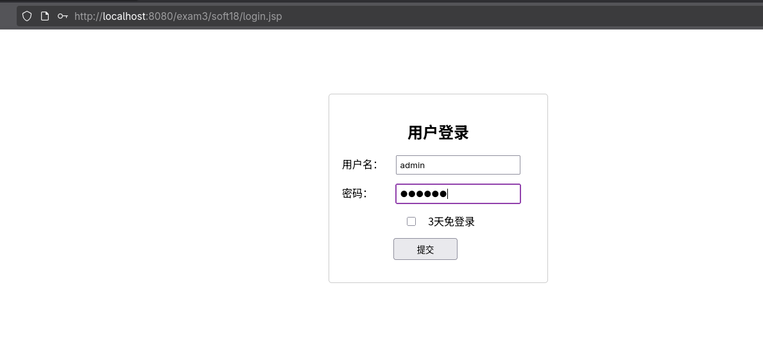
welcome页面:

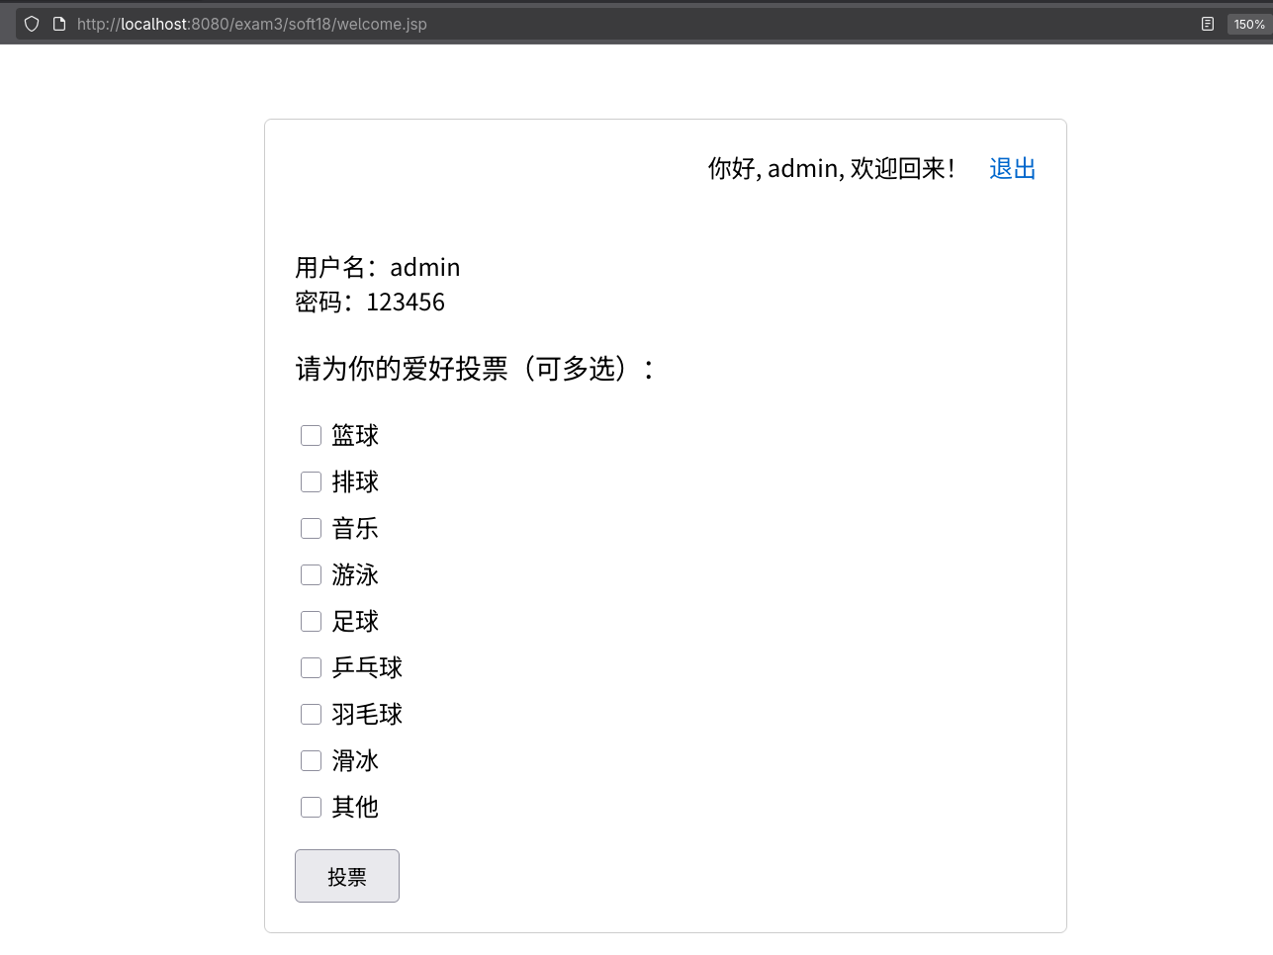
点击退出按钮回到登陆页：
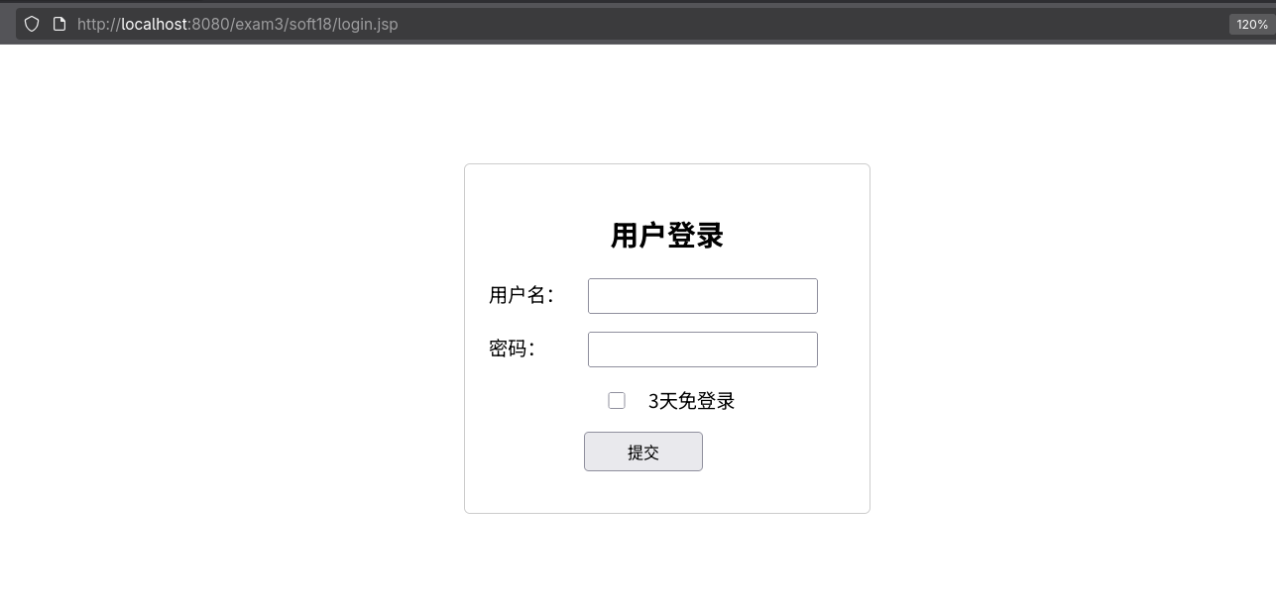
投票页面：
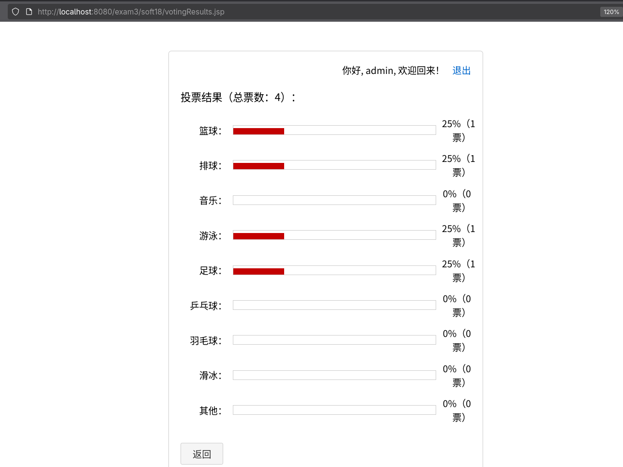

- 结果分析与实验体会
通过这次实验，我掌握了如何编写jsp文件和servlet文件，servlet可以实现客户端提交过来的账号密码的存储和判断，并且还可以使用Cookie和Session的技术实现免登陆。

